**Problem Statement:** A large company named XYZ, employs, at any given point of time, around 4000 employees. However, every year, around 15% of its employees leave the company and need to be replaced with the talent pool available in the job market. The management believes that this level of attrition (employees leaving, either on their own or because they got fired) is bad for the company, because of the following reasons -

● A sizable department has to be maintained, for the purposes of recruiting new talent  
● More often than not, the new employees have to be trained for the job and/or given time to acclimatize themselves to the company  
● Hence, the management has contracted an HR analytics firm to understand what factors they should focus on, in order to curb attrition.  
● In other words, they want to know what changes they should make to their workplace, in order to get most of their employees to stay.  
● Also, they want to know which of these variables is most important and needs to be addressed right away.

Since you are one of the star analysts at the firm, this project has been given to you.

Goal of the case study You are required to model the probability of attrition. The results thus obtained will be used by the management to understand what changes they should make to their workplace, in order to get most of their employees to stay.

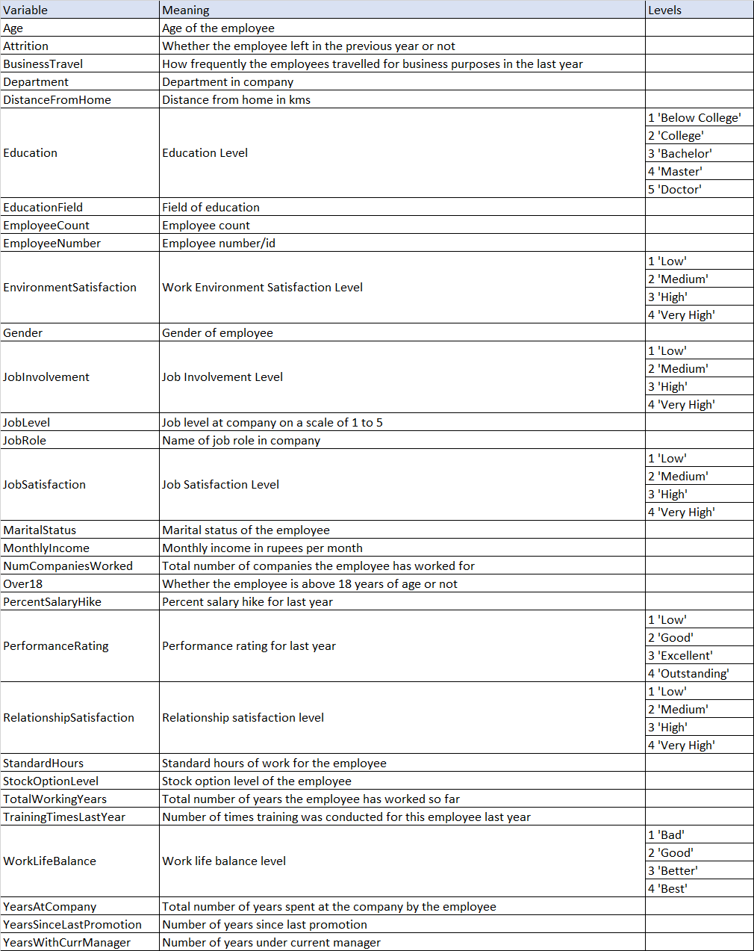

**Hypothesis Statement 1:** The average distance from home of the employees who left the company is 5 unit. Taking sample size 100, confidence level = 0.05 and sample standard deviation = 5.89.

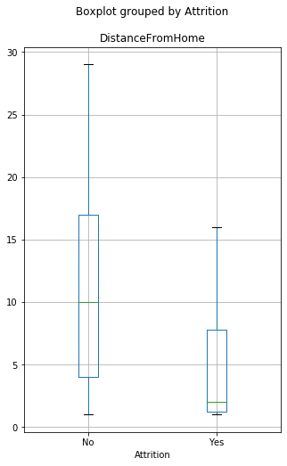

**Hypothesis Statement 2:** The average monthly income of the employees who left the company is 75000. Taking sample size 100, confidence level = 0.05 and population standard deviation = 57902.89.

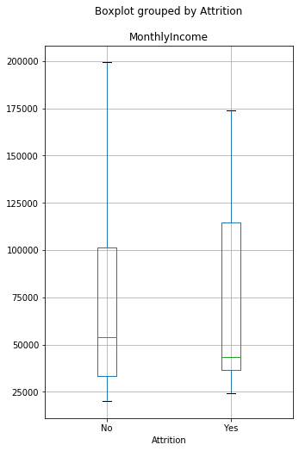

**Hypothesis Statement 3:** The average number of companies where the employees who left the company previously worked is greater than equal to 3. Taking sample size 100, confidence level = 0.05 and sample standard deviation = 2.18.

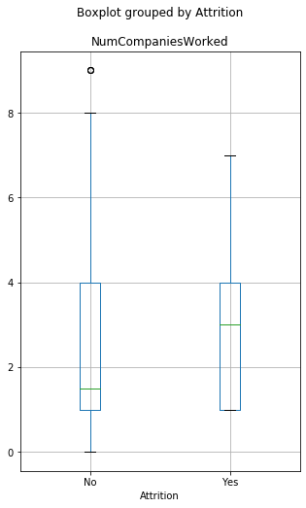

**Hypothesis Statement 4:** The average percent salary hike of the employees who left the company is less than equal to 15.5. Taking sample size 100, confidence level = 0.05 and sample standard deviation = 3.13.

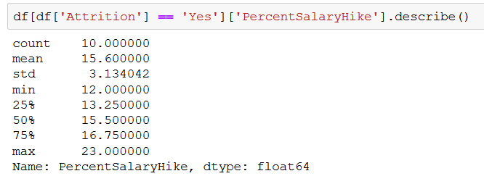

**Hypothesis Statement 5:** The average Stock Option Level of the employees who left the company is 1. Taking sample size 100, confidence level = 0.05 and sample standard deviation = 0.67.

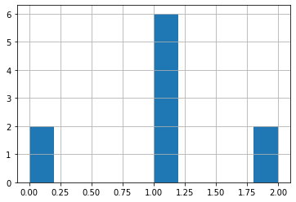

**Hypothesis Statement 6:** The average number of working years of the employees who left the company is less than equal to 10. Taking sample size 100, confidence level = 0.05 and sample standard deviation = 11.86.

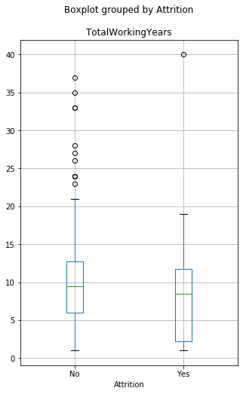

**Hypothesis Statement 7:** The average number of trainings the employees who left the company attended last year is 2. Taking sample size 100, confidence level = 0.05 and sample standard deviation = 1.15.

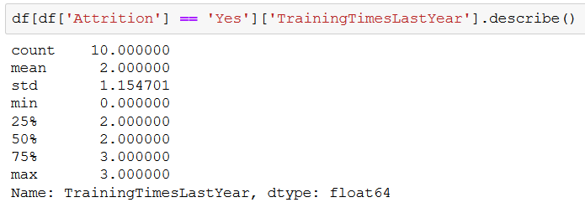

**Hypothesis Statement 8:** The average number of years the employees who left the company were with the company is less than equal to 5. Taking sample size 100, confidence level = 0.05 and sample standard deviation = 12.1.

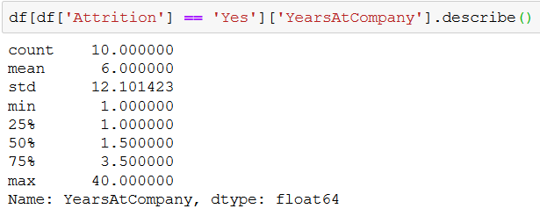

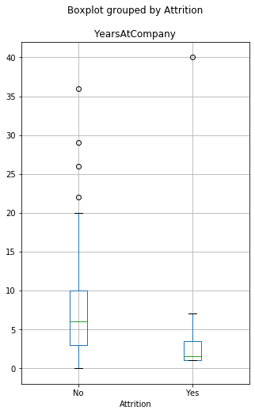

**Hypothesis Statement 9:** The average number of years since the last promotion of the employees who left the company is less than equal to 2. Taking sample size 100, confidence level = 0.05 and sample standard deviation = 4.68.

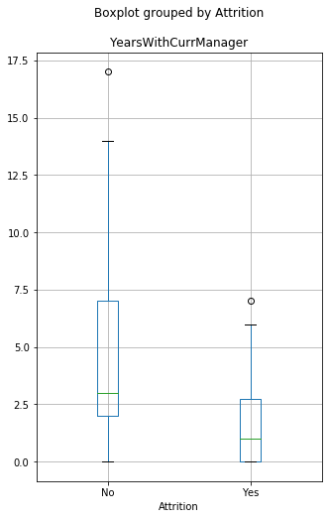

**Hypothesis Statement 10:** The average number of years the employees who left the company were with their current managers is less than equal to 2. Taking sample size 100, confidence level = 0.05 and sample standard deviation = 2.62.

